A CRITICAL ANALYSIS OF SPATIAL ANALYSIS

BY

MARVIS ESIVUE

TABLE OF CONTENTS
INTRODUCTION---------------------------------------------------------------------------------------------------3
WHAT IS SPATIAL ANALYSIS? ----------------------------------------------------------------------------------3
WHAT IS NON-SPATIAL ANALYSIS? --------------------------------------------------------------------------6
DIFFRENCIATING BETWEEN SPATIAL AND NON-SPATIAL ANALYSIS---------------------------------7
DISCUSSING SPATIAL ANALYSIS TECHNIQUES-------------------------------------------------------------8
MEASURING GEOGRAPHICAL DISTRIBUTION TECHNIQUE–– Measuring Speckled wood butterflies mean center and standard distance----------------------------------------------------------9
ANALYSING PATTERNS TECHNIQUES: USING KERNEL DENSITY AND AVERAGE NEAREST NEIGHBOUR TO ANALYZE BURGLARY IN SOUTH YORKSHIRE. --------------------------------------12
Thiessen Polygon------------------------------------------------------------------------------------------------15
CONCLUSION-----------------------------------------------------------------------------------------------------19
REFRENCES--------------------------------------------------------------------------------------------------------19

A CRITICAL ANALYSIS OF SPATIAL ANALYSIS

INTRODUCTION
Comprehending spatial linkages and patterns is essential in many fields, including influencing decision-making and clarifying complicated occurrences. Deep insights into geographical data can be gained by spatial analysis, which makes use of tools like GIS and spatial modeling. Examining the approaches, constraints, and underlying presumptions of spatial analysis is the goal of this critical analysis. This study will explore the concept of spatial analysis and traditional statistical techniques, their similarities and evaluate the effectiveness of spatial analysis tools in solving socio-political and environmental concerns via the lenses of critical geography and socio-spatial theory. This report aims to shed light on these approaches by drawing out their key elements, practical application, and potential for progress by examining their limitations and implications.

WHAT IS SPATIAL ANALYSIS?
By utilizing the topological, geometric, or geographic aspects of the variables, spatial analysis, also known as spatial statistics, ascertains the link between the variables. To do routine inspections, evaluations, assessments, and analyses of various places, spatial analysis aids in the extraction of fresh information about defined sets of coordinates (Brynne, 2023). This definition highlights the significance of the use of spatial analysis, which uses variables such as geographic properties to create relationships between them and how Routine inspections, assessments, evaluations, and analyses of various locations are made easier by spatial analysis, which also makes it possible to extract new information from coordinate sets. It also explains that spatial analysis examines correlations and trends between different geographically referenced data sets. It explains that it facilitates the understanding of the interactions between various factors within certain locations or areas by integrating geometric and geographical aspects, it offers insightful information about spatial linkages and supports well-informed decision-making.
Spatial analysis entails Studying different entities through the inspection, measurement, appraisal, and modeling of geographical data features such as geographic locations, characteristics, and linkages that expose geometric or geographic elements of the data (Vijay, 2022). This definition of spatial analysis is comprehensive. It encompasses the investigation and interpretation of spatial data to ascertain the characteristics, trends, and connections related to geographic aspects. Using computational models, algorithms, and analytical tools, spatial analysis interprets geographic data to assess its application and usefulness within a given system or environment.

Another definition of spatial analysis explains that it focuses on converting geographic characteristics into quantitative analysis ready data points. This can involve applying features to statistical analysis or machine learning, such as location, boundaries, networks, and distances between locations (Gunn.E, 2023). This definition of spatial analysis highlights its focus on converting geographic characteristics into quantitative data points suitable for analysis. It involves the utilization of various geographical features like location, boundaries, networks, and distances between locations. This data is then applied to statistical analysis or machine learning methods, enabling a deeper understanding and extraction of meaningful insights from spatially referenced information.

In spatial statistical analysis, an understanding of a process is utilized to forecast the possible spatial patterns that emerge, and an examination of one or more of its realizations establishes the probability that any observed pattern is a product of this process. Conversely, exploratory spatial data analysis looks at a distribution that has been seen and tries to deduce how it came about. (David. J. W, 1996). Complex location-based problems can be solved with spatial analysis, which also enables people to examine and understand data from a geographic perspective, create relationships, identify, and quantify patterns, monitor trends, and forecast predictions and decisions (Esri, 2013). The core of GIS is spatial analysis. The process of giving geographic data more value is what makes it possible to transform data into knowledge and information that is helpful. Spatial analysis is a data mining technique that assists GIS users in identifying patterns, correlations, and inherent anomalies in GIS data sets that may not be readily evident otherwise (Joseph. L.A & John B.K, 2013).
One of the very first recorded uses of spatial analysis is a very good example of the techniques used by John Snow in 1854. John Snow tracked the source of a cholera outbreak in London. using the power of mapping and spatial analysis (Gilbert. E.W & Kari. S.M, 2000). By mapping the locations of cholera-related deaths, he was able to identify the source of the outbreak and discern a distinct pattern that had gone unnoticed by others. Figure 1 below shows a map of cholera outbreaks in London created by John snow. Even though the word "GIS" did not exist in 1854, the map of cholera deaths created by John Snow gave him the same kind of access to information that we do today to ask questions and find answers.

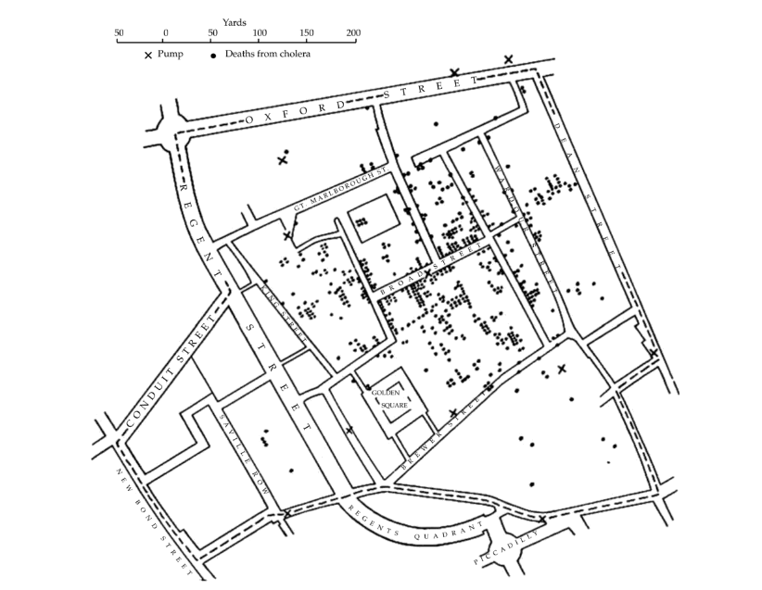
Figure 1 -
John Snow's 1854 map of London cholera outbreaks (deaths are indicated as dots, water pumps as crosses). Gilbert Publishing reproduced.
Source: (Kari. S.M, 2000).

Aside from analyzing patterns, another example of spatial analysis is proximity analysis. A networked route can be applied to track the distance from points A and B, or it can be calculated as a straight line. (Volusia County Florida, 2024). For instance, being close to the highways and the airport may be important considerations when choosing a location for a manufacturing plant if a prospective client is interested in building one in the Daytona Beach region in the area shown in figure 2 below. A GIS user only needs to click on the point locations that represent the site, the interstate exit ramp, and the airport to get an estimate of the distance. Once the distances are known, the database can be used to look up other pertinent information, like labor availability, acreage cost, and water and sewer services. Figure 2 below represents a map showing the proximity analysis of Site A which is the point of interest to other factors that might be of important consideration such as airports, interstates (Volusia County Florida, 2024).

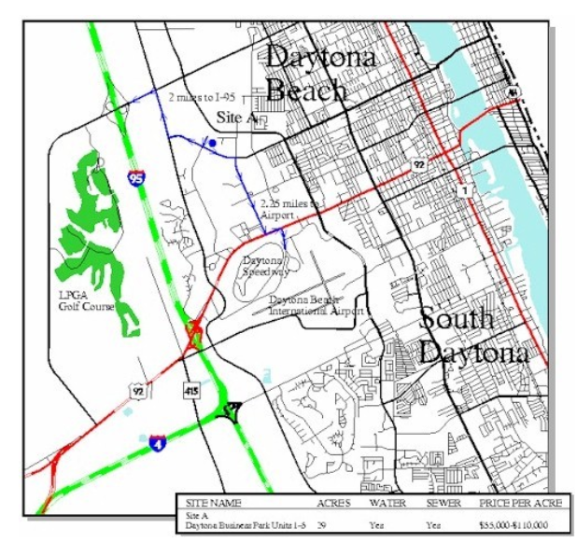
Figure 2, showing locations that represent the location of site, airport, and the interstate exit ramp to get an estimate of the distance using proximity analysis.
Source: (Volusia County Florida, 2024)

WHAT IS NON-SPATIAL ANALYSIS?
Analyzing and interpreting data that does not naturally contain a geographic or spatial component is known as non-spatial analysis (Nicole. L ,2021). It entails analyzing data without considering its location-based attributes or geographical context. Numerical data, textual data, categorical data, and any other kind of data without explicit geographic coordinates or relationships are the main subjects of this kind of analysis (Spatialpost, 2023).
There are two major types of Non spatial analysis which are Descriptive and Inferential statistics.
Descriptive statistics involves summarizing data in a meaningful way such that patterns may emerge, it is one way to achieve descriptive analytics as it is an assortment of instruments that provide a quantitative, graphical, and summary version of the data (Venkat. N.G, 2017). They include:
- Standard set of exploratory techniques
- Central tendency (mean, median and mode)
- Dispersion (standard deviation, variance, inter quartile, semi-interquartile range etc.)
A database with a very high number of measurements can be used to determine the location and dispersion of the data using the mean and standard deviation. This broad strategy can be a very helpful instrument (Brunsdon. C & Fotheringham. A.S., et al, 2002). On the other hand, Inferential statistics involves inferring something about the population from the sample. It is possible to propose explanations for a condition or event using inferential statistics, this makes it fundamentally distinct from descriptive statistics, which only report the measured data as it enables you to make inferences based on extrapolations (Richard. C & Bruce. Y.L, 2008). Inferential statistics could include:
- Testing how much confidence we have in a sample.
- Comparing one sample outcome to another
Non-statistical techniques are very valuable because they enable you to make statements about the larger world and go beyond merely describing the facts you have gathered. Inference is the process by which you go from merely describing what you can see to drawing wider conclusions (McCarroll. D, 2016).
Non-spatial analysis can also include, for example, the analysis of financial records, survey responses, sales figures, demographic data, list of reference values, postal addresses and any other dataset that does not contain geographic references by nature (1spatial, n.d.).

DIFFRENCIATING BETWEEN SPATIAL AND NON-SPATIAL ANALYSIS
Examining and comprehending patterns, relationships, and processes that take place geographically or within space is the goal of spatial analysis. It examines how various phenomena relate to one another in a spatial setting and works with geographic data. Spatial modeling, spatial statistics, geographic information systems (GIS), and mapping are a few examples of this. On the other hand, non-spatial analysis describes the study of data or events without considering their physical or geographic environment. It concentrates on relationship analysis or information analysis without taking geographical distribution or location-based patterns into account. Traditional statistical analysis, data mining, and other quantitative analysis techniques that ignore spatial linkages are a few examples. It deals with statistical, quantitative, or qualitative methods applied to non-geographic data, such as demographic surveys, financial data, or social science research. Both types of analysis have their strengths: spatial analysis is useful for understanding spatial patterns and relationships, while non-spatial analysis is valuable for studying broader trends and correlations regardless of location. The choice between these approaches depends on the nature of the data.
Notwithstanding their different focuses, spatial and non-spatial analysis have some things in common. Examining and modifying data is a part of both spatial and non-spatial analysis. They make use of a variety of techniques and resources to glean insightful information from the data at hand. Statistical approaches are frequently utilized in both types of analysis to identify patterns, relationships, trends, and correlations within the data. Non-spatial analysis applies conventional statistical techniques to non-geographical datasets, whereas spatial analysis incorporates spatial statistics unique to geographical data. Both strategies use data analysis to try and solve issues or get new perspectives. They support decision-making processes in both market analysis through non-spatial methodologies and urban planning through spatial analysis. Technological developments are advantageous to both spatial and non-spatial analyses. Both kinds of analysis are supported by Geographic Information Systems (GIS), statistical software, machine learning algorithms, and other tools for effective data processing and interpretation. In terms of Multidisciplinary Approach, both disciplines are applied in many different contexts and are multidisciplinary. While non-spatial analysis is used in domains like economics, healthcare, social sciences, and business, spatial analysis is applied in geography, urban planning, environmental science, and other areas. While their approaches to data analysis and problem-solving are similar, the main difference between them is that spatial analysis considers the spatial context, whereas non-spatial analysis only considers the attributes and relationships of the data without considering any spatial constraints.
The exact environment, industry, and type of data being examined determine how much geographical and non-spatial analysis is used. Because non-spatial analysis is more broadly applicable to a wider range of subjects, including business, social sciences, economics, and healthcare, it has historically been more common.
But thanks to technological improvements and the increasing significance of geographic data, spatial analysis—and Geographic Information Systems in particular—has become quite popular. In domains such as emergency services, transportation, natural resource management, environmental science, and urban planning, its significance has grown. With the advent of multidisciplinary research and the growing realization of the significance of geographic context in data analysis across different domains, there has been a growing tendency in recent years towards the integration of both spatial and non-spatial analysis methodologies. Because both geographical linkages and non-spatial features are considered at the same time, this integration makes it possible to interpret data more thoroughly. Therefore, the rising availability of geographical data and the necessity to comprehend spatial linkages have led to the development in importance and application of spatial analysis techniques in several domains, even though non-spatial analysis is still widely used across many industries.

DISCUSSING SPATIAL ANALYSIS TECHNIQUES
Spatial analysis techniques encompass a diverse array of methodologies crucial in unravelling patterns, relationships, and trends within geographic data. This section aims to discuss and investigate various spatial analysis techniques such as measuring geographic distribution, analyzing patterns such as kernel density and average nearest neighbor and Thiessen polygon, while explaining their purpose, their strengths, weaknesses and to shed light on the interpretation of their outputs in relation to the spatial question set, and see how each technique relates to traditional statistical approaches if applicable.
1. MEASURING GEOGRAPHICAL DISTRIBUTION TECHNIQUE– Measuring Speckled wood butterflies mean center and standard distance
Describing the technique:
The mean center is displayed as a point created by averaging the x, y, and z values if applicable, for the centroids of the input features. Forecast data is required for this tool to estimate distances accurately. The characteristics of the output feature class are the x, y, and z values for the mean center point features. The values can be found in the XCOORD, YCOORD, and ZCOORD fields. (Esri, n.d.). On the other hand, the standard distance determines how evenly or unevenly features are distributed around the geometric mean center. The center of the resultant data is a circle, representing the mean center of all sample data, whereas the standard deviation of all data is a radius-centered circle. The concentration of all the data on the average center is thus represented by the circle; the narrower the radius, the higher the concentration (Supermap, 2024).
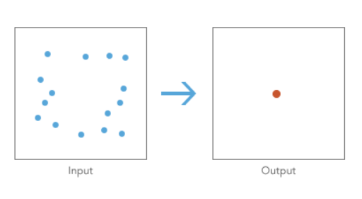
Figure 3- Image showing the output of the mean center.
Source: (Esri, n.d.)
Background:
Though less frequent in Scotland, Speckled wood butterflies are common and distributed throughout the United Kingdom. Between April and September, you can find them in parks, gardens, hedgerows, and woodland glades and rides (Woodland Trust, n.d.). This butterfly's distribution shrank in the late 19th and early 20th centuries, but it has subsequently expanded again since the 1920s. Over the past 20 years, it has persisted in spreading and has returned to many parts of Scotland and eastern and northern England (Butterfly Conservation, n.d.). Figure 4 below, shows the geographic distribution of Speckled wood butterflies mean center points which was determined by using an equal interval of different years (1901 - 2001) and Figure 5 below shows the standard distance from the mean center points starting in 1901 and ending in 2001

MAP SHOWING SPECKLED WOOD BUTTERFLY MEAN CENTER
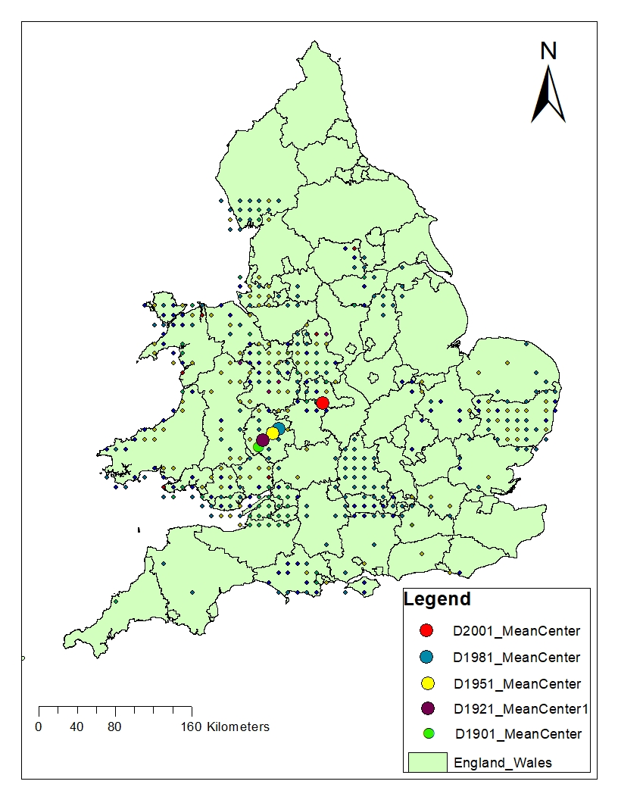
Figure 4 – showing the mean center for Speckled wood butterflies
SOURCE: Authors Analysis(Contains OS data)

MAP SHOWING SPECKLED WOOD BUTTERFLY STANDARD DISTANCE
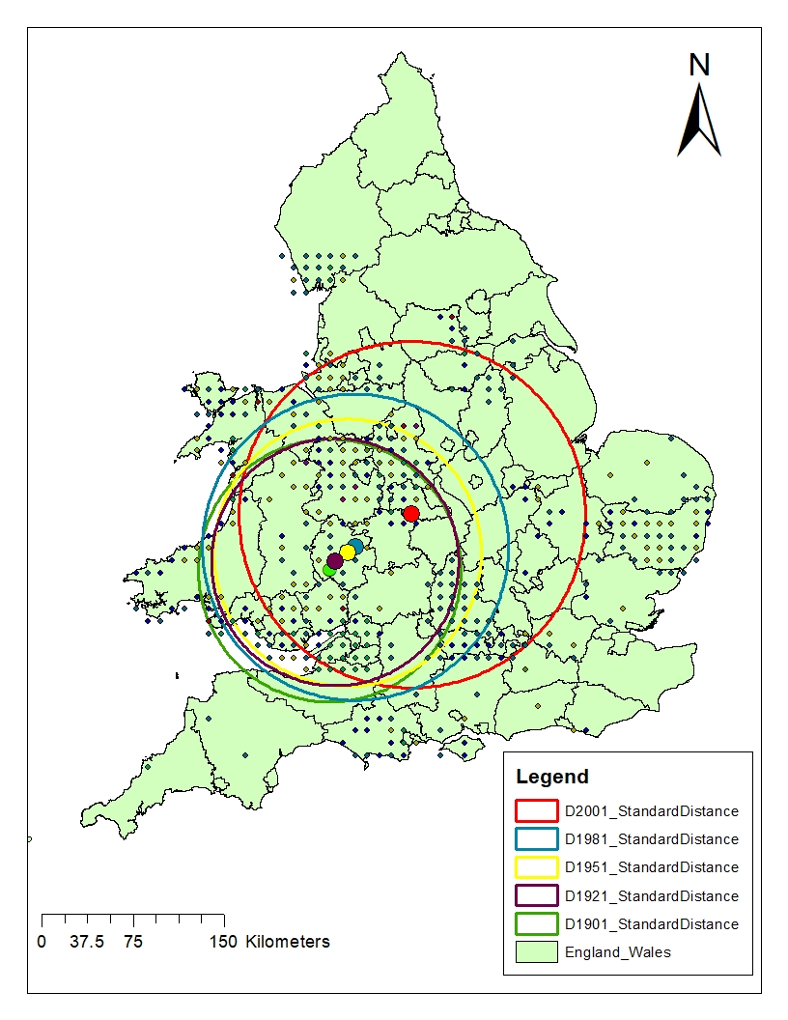
Figure 5- Showing the standard distance for Speckled wood butterflies.
SOURCE: Authors Analysis (Contains OS data)

CONCLUDING THE ANALYSIS
From the analysis above, we could see that the map in figure 4 demonstrates how the mean center of the Speckled wood butterfly’s distribution shifted over the years with the biggest shift occurring in 2001, looking at figure 4 above it seems the speckle wood butterflies shifted from the southwest to the northeast. The standard distance analysis shows the radius of the distribution of the speckle wood butterflies, looking at the map in figure 5 the standard distance analysis shows that the radius of the speckle wood butterflies has been increasing with the year 2001 having a much larger radius.

COMPARING ANALYZING PATTERNS TECHNIQUES WITH NON-SPATIAL TECHNIQUES
Non-Spatial techniques like mean and standard deviation is similar to the mean center and standard distance technique, the mean is the total of the sum of all values in a collection of numbers divided by the number of numbers in a collection (Sebastian. T, 2024), On the other hand, the most basic description of a geographic distribution is the Mean Center which is the average of the X and Y coordinates for every feature in a studied area (Geospatiality, 2017). They both can track changes in a distribution over specific time. Similar to how a standard deviation assesses the distribution of data values around the statistical mean, the standard distance is a helpful statistic since it offers a single summary assessment of the feature distribution around their center (Esri, 2013).

2. ANALYSING PATTERNS TECHNIQUES: USING KERNEL DENSITY AND AVERAGE NEAREST NEIGHBOUR TO ANALYZE BURGLARY IN SOUTH YORKSHIRE.
Description of the techniques:
One helpful method for visualizing point data is Kernel Density. Despite being easy to use, the outputs produced depend on the given parameters (Esri, n.d.). The Kernel Density Estimation Tool (KDE) is a density estimation method that builds a smooth approximation by averaging a known density function (the kernel) over observed data points (Budde, 2019). The nearest neighbour index is determined by averaging the distances between each feature and its closest neighbouring feature. By dividing the observed mean distance by the expected mean distance, one can compute the nearest neighbour index. The expected distance in a theoretical random distribution is the mean distance between neighbours. If the index is less than one, the pattern is clustering; if the index is larger than one, the pattern is dispersed or competitive.
BACKGROUND
Provided with data from police database for crimes in South Yorkshire in October 2015, with burglary being singled out to be analyzed to know if burglary around South Yorkshire is clustered, dispersed, or randomized, Kernel density analysis was carried out. Figure 6 below shows a map showing Kernel density analysis using ArcGIS. Using the same data, Average Nearest neighbor spatial analysis was also carried out.
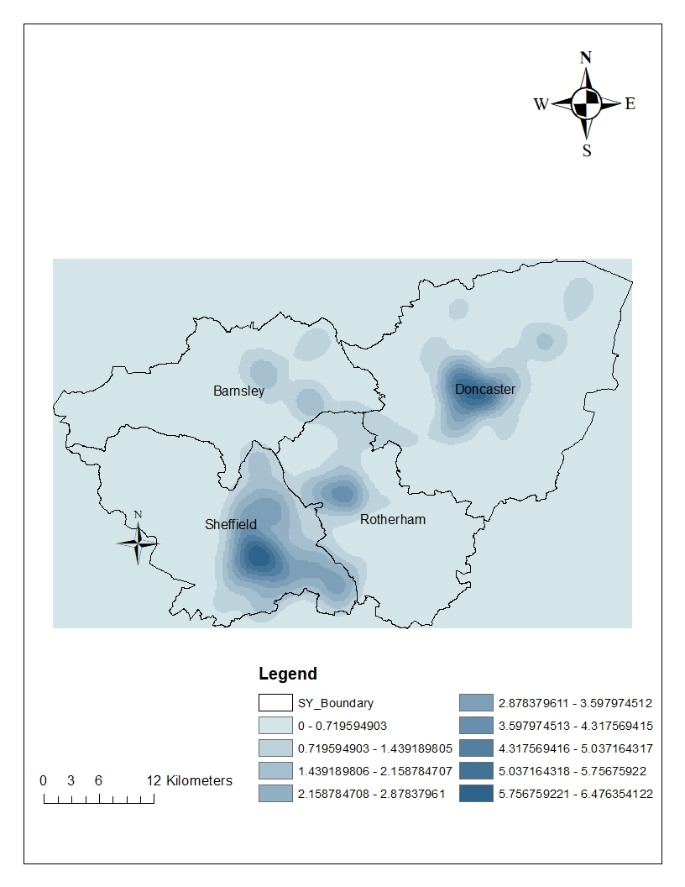Figure 6 – A map displaying South Yorkshire burglary kernel density analysis.
SOURCE: Authors Analysis (Contains OS data)

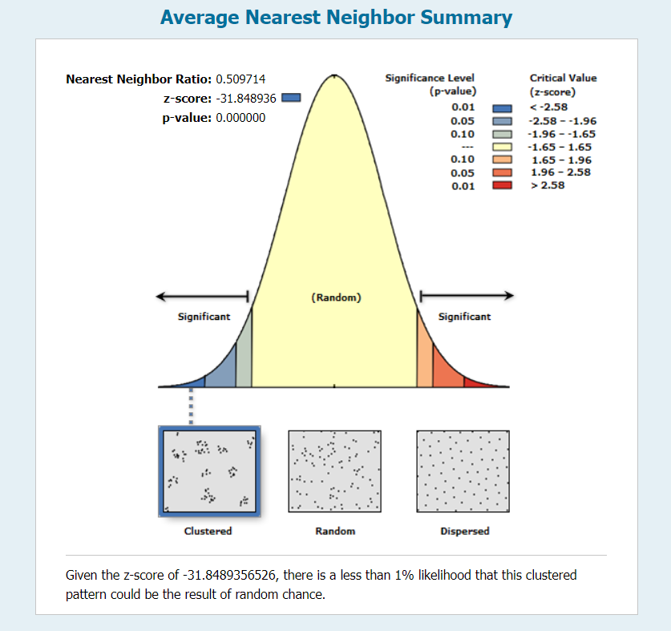
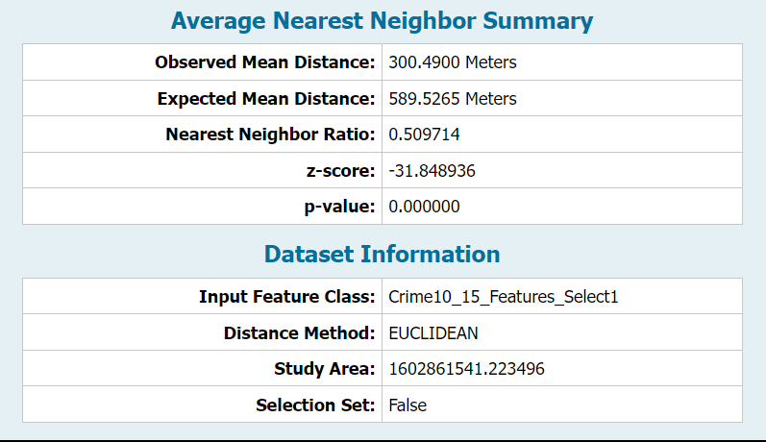
Figure 7- average nearest neighbor summary
Source: Authors Analysis

CONCLUDING THE ANALYSIS
The kernel density analysis above shows there is clustering around the area of Sheffield, Doncaster, and parts of Rotherham. The average nearest neighbor analysis confirmed that given the z score of -31.8489356526, there is a less than 1% likelihood that this clustered pattern could be the result of random chance.
ANALYZING THE TECHNIQUE
It is especially beneficial for identifying patterns and hotspots in data without the need for present limits or zone. A Kernel function is used to define the shape and size of the smoothing window surrounding each point. Kernel density analysis builds a surface by putting these windows over the data points and totaling their contributions. Areas with greater densities imply more concentrated point occurrences. While kernel density is a valuable tool for researching distributions, its limitations, such as sensitivity to kernel function and bandwidth selection, must be noted. The Distance between each point and its nearest neighbor is computed by the Average nearest neighbor. The observed average closest neighbor distance is the average of these nearest neighbor distances over all places.
COMPARING ANALYZING PATTERNS TECHNIQUES WITH NON-SPATIAL TECHNIQUES
Non spatial techniques like measuring variance, skewness, kurtosis is like analyzing patterns techniques as this method investigates the distribution of values within a dataset. And concentrates on the frequency of occurrences of values but ignores the geographical link between the data points.

3. PROXIMITY ANALYSIS - USING THIESSEN POLYGON TO ANALYZE LONDON CHOLERA OUTBREAK IN 1854
Describing the technique:
Thiessen polygons are created by taking a set of sample points and dividing them into polygons that, at any given place inside the polygon, are all closer to the sample point than the other polygons (Caliper, 2023). Thiessen polygons are a crucial tool for neighborhood and proximity studies. The closest point feature is given space using Thiessen polygons. It delineates a region surrounding a point, where all locations are closer to this point than they are to any other point (Gitta, 2016). Since it was first introduced by Thiessen from the Voronoi diagram in mathematics at the beginning of the twentieth century, the Thiessen polygon method has played a significant role in hydrology and meteorology for estimating average rainfall (and other hydrometeorological factors, such as solar radiation) over a bounded area (Han. D & Bray. M, 2006).
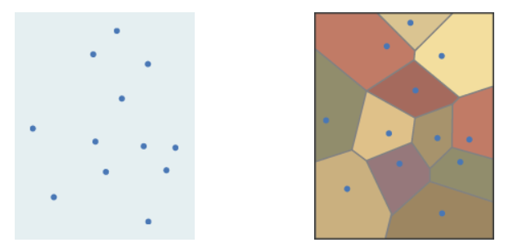
INPUT OUTPUT
Figure 8 – Showing the output of the Thiessen polygon.
Source: (Gitta, 2016)

BACKGROUND:
One of the scariest illness outbreaks in Western history took place in London, England, in August of 1854. Ten percent of Soho's population had contracted cholera in just one week, and the outbreak only became worse as people fled in panic (Esri, n.d.)John Snow is frequently recognized as the pioneer of analytic mapping in the modern era for being the first to employ the Thiessen polygon, which is used to map one source of locational data upon another (Mcleod & Brody., et al, 2000). Using the location of the water sources as an example, this basic kind of proximity analysis establishes catchment areas based on the proximity of point-based data variables. (Mcleod & Brody., et al, 2000)

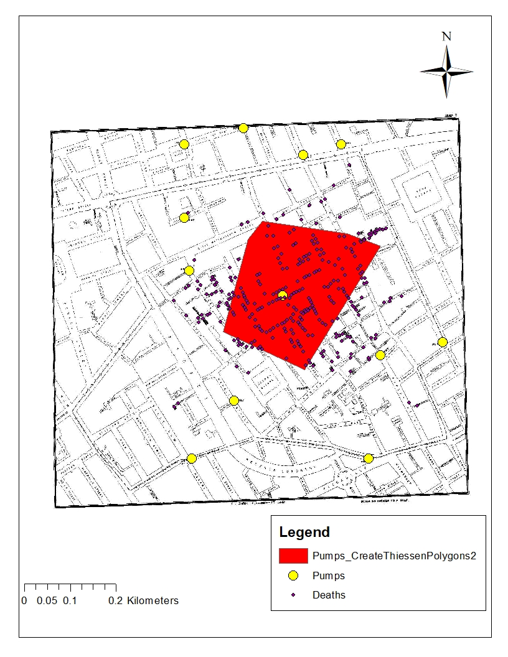
Figure 9 – Showing the john snow map pumps and death.
Source: Authors Analysis (Contains OS data)

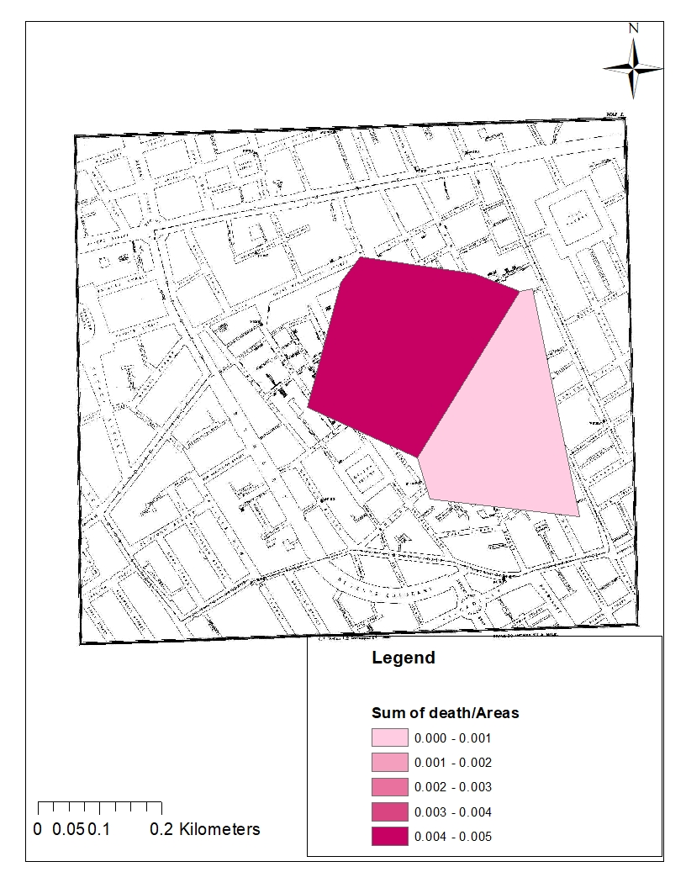
FIGURE 10 – Showing the sum of deaths/ Area of the Thiessen polygon.

CONCLUDING THE ANALYSIS
The Thiessen polygon analysis in Figure 9 indicates the approximate region where the broad street water pump supplied water to the cholera victims, with that area having the highest number of deaths when calculated per zone (348 in total). There were 1–72 recorded deaths in the area where 8 more pumps were located, with no death in 3 areas with pumps. Figure 10 shows the sum of death per area using a scale of 0 – 0.2 km.
ANALYZING THE TECHNIQUES AND COMPARING IT WITH NON-SPATIAL TECHNIQUES
There is no direct counterpart in non-spatial techniques for the Thiessen polygon method used in spatial analysis. Nonetheless, non-spatial analysis encompasses techniques that aim to assign closeness or areas of influence without taking spatial links into explicit consideration.

CONCLUSION
The critical examination of both spatial and non-spatial analytical approaches highlights their complimentary roles in thoroughly comprehending varied phenomena. Spatial analysis, which focuses on geographical links and patterns, provides unique insights into geographically referenced data, so assisting in decision-making, urban planning, and environmental management. Non-spatial analytic methodologies, on the other hand, stressing statistical and qualitative approaches, dive into larger contexts, allowing for a greater knowledge of social, economic, and behavioral factors regardless of geographical components. Recognizing each approach's strengths and limitations is critical for effective integration. Spatial analysis adds geographic elements to non-spatial studies, whereas non-spatial analyses provide a comprehensive perspective that transcends territorial limits. However, issues like data quality, interpretational biases, and the complexities of multidisciplinary integration continue.
WORD COUNT - 3675

REFRENCES
1spatial. (n.d.). Data Extents and Non-spatial Data. (n.d.). Retrievedfrom:https://1spatial.com/documentation/1integratearcgis/v2/Topics/Validating_Enhancing/Data_Extents.htm
An overview of the Measuring Geographic Distributions toolset—ArcGIS Pro | Documentation. (n.d.). https://pro.arcgis.com/en/pro-app/latest/tool-reference/spatial-statistics/an-overview-of-the-measuring-geographic-distributions-toolset.htm
Brunsdon, C., Fotheringham, A.S. and Charlton, M. (2002). Geographically weighted summary statistics—a framework for localised exploratory data analysis. Computers, Environment and Urban Systems, 26(6), pp.501-524.

Brody. H. M & Vinten. P., et al. (2000). Map making and myth making in broad street: The London cholera epidemic, 1854, The Lancet 356, 64.
http://www.ph.ucla.edu/epi/snow/mapmyth/mapmyth.html.

Budde. (2019, February 21). Kernel density analysis – a tool for the visualization of spatial patterns in regional studies. Retrieved December 9, 2023, from https://rural-urban.eu/sites/default/files/02_Kernel%20Density%20Analysis_Budde.pdf

Butterfly Conservation. (n.d.). Speckled Wood.
https://butterfly-conservation.org/butterflies/speckled-wood

Brynne.R.(2023). What is spatial analysis? How it benefits Geospatial understanding
Retrieved from: What Is Spatial Analysis? How It Benefits Geospatial Understanding (g2.com)

Caliper. (2023). What is a Thiessen Polygon?
https://www.caliper.com/glossary/what-is-a-thiessen-polygon.htm

Cory L.E & Cynthia A.B. (2013). Dasymetric Mapping and Areal Interpolation; Implementation and Evaluation. Pages 125-138 https://doi.org/10.1559/152304001782173727

David. J.U. (1996). GIS, spatial analysis, and spatial statistics| progress in Human Geography 20,4 pp. 540-551

https://journals.sagepub.com/doi/epdf/10.1177/030913259602000408

Dirk U & Timothy P et al. (2008). Spatial Analysis in Epidemiology. Google Books. https://books.google.co.uk/books?hl=en&lr=&id=wQlREAAAQBAJ&oi=fnd&pg=PR5&dq=example+of+spatial+analysis

Esri. (2013). Standard Distance (Spatial Statistics)
https://pro.arcgis.com/en/pro-app/latest/tool-reference/spatial-statistics/standard-distance.htm

Esri. (2013). The Language of Spatial Analysis
Retrieved from: The Language of Spatial Analysis (esri.com)

Esri.(2013). Spatial analysis in ArcGIS Pro—ArcGIS Pro | Documentation. Retrievedfrom:https://pro.arcgis.com/en/pro-app/latest/help/analysis/introduction/spatial-analysis-in-arcgis-pro.htm
Esri. (n.d.). Map a historic cholera outbreak. | Documentation (n.d.). Retrievedfrom: https://learn.arcgis.com/en/projects/map-a-historic-cholera-outbreak/#:~:text=The%20map%20he%20created%20based,for%20the%20study%20of%20epidemiology.
Esri.(n.d.)PublicInformationMap. https://www.arcgis.com/apps/PublicInformation/index.html?appid=d7deb67f810d46dfacb0ff80ac224e9&fbclid=IwAR3LoKHUTfpiH5Yy9iASdeClqIIfRwsJm065d-_JiNtB2tfrl-DAHUTTNdU
Geospatiality. (2017). Measuring geographic distribution- mean center
https://glenbambrick.com/2017/03/21/calculating-the-mean-center/
Gilbert, E. W. (1958). Pioneer Maps of Health and Disease in England. The Geographical Journal, 124(2), 172–183. https://doi.org/10.2307/1790244

GITTA.(2016). Thiessen Polygon
http://www.gitta.info/Accessibilit/en/html/UncProxAnaly_learningObject4.html

Gunn, E. (2023, October 4). What Is Spatial Analysis, and How Does It Work? CareerFoundry. https://careerfoundry.com/en/blog/data-analytics/spatial-analysis/
Glen, B. (2017, April 26). OSGP: Measuring Geographic Distributions - Standard Distance|Geospatially. https://glenbambrick.com/tag/standard-distance/

Han. D & Bray. M. (2006). Automated Thiessen polygon generation. Volume 42, Issue 11
https://doi.org/10.1029/2005WR004365

Joseph. L.A & John. B.K. (2013). Spatial Analysis. In: Environmental Geoinformatics. Environmental Science and Engineering(). Springer, Berlin, Heidelberg.
https://doi.org/10.1007/978-3-642-34085-7_17

Kari. S.M. (2000). Our sense of snow: the myth of John snow in medical geography. |Volume 50, Issues 7-8, pp 923-935
https://doi.org/10.1016/S0277-9536(99)00345-7
McCarroll, D. (2016). Simple statistical tests for geography. Boca Raton: Chapman & Hall/CRC. ISBN 9781498758819

Mclead. K. (2000). Our sense of snow: The myth of john snow in medical geography, social science and medicine 40 (7&8): 923-936
Mean Center (Spatial Statistics)—ArcGIS Pro | Documentation. (n.d.). https://pro.arcgis.com/en/proapp/latest/toolreference/spatialstatistics/meancenter.htm#:~:text=The%20mean%20center%20is%20a,in%20the%20Output%20Feature%20Class.
Mitchell A. (2021). Esri Guide to Gis Analysis, vol 2. ISBN-13:9781589481169
https://wordery.com/esri-guide-to-gis-analysis-v-2-andy-mitchell-
Nicole. L. (2021).What is Spatial Data and Non-Spatial Data?: what is the difference? | Safe Retrievedfrom:https://engage.safe.com/blog/2021/10/non-spatial-data-difference-fme/#:~:text=October%2025%2C%202021,is%20independent%20of%20geographic%20location.
Nicholas N.N, Barbara P.B et al. (2013). Dasymetric Modeling and Uncertainty. Pages 80-95. https://doi.org/10.1080/00045608.2013.843439

Richard. C & Bruce. Y.L. (2008). Principles and practices of clinical trial medicine | ISBN 978-0-12-373695-6
https://doi.org/10.1016/B978-0-12-373695-6.X0001-4

Sebastian. T.(). Mean | What is mean?. CFI
https://corporatefinanceinstitute.com/resources/data-science/mean/
Spatialpost. (2023, June 17). Difference Between Spatial and Non-Spatial Data: An In-Depth Understanding | Spatial Post. Spatial Post. Retrieved from:https://www.spatialpost.com/difference-spatial-and-non-spatial-data/#Definition_of_Non-Spatial_Data

Supermap. (2024). Standard Distance. https://help.supermap.com/iDesktop/en/tutorial/Analyst/SpatialStatisticalAnalysis/MeasureStandardDistance

Supermap.(n.d.).meancenter https://help.supermap.com/iDesktop/en/tutorial/Analyst/SpatialStatisticalAnalysis/MeanCenter/
Swanwick, R.H., Read, Q.D., Guinn, S.M. et al. (2022). Dasymetric population mapping based on US census data and 30-m gridded estimates of impervious surface. Sci Data 9, 523. https://doi.org/10.1038/s41597-022-01603-z

Venkat. N.G. (2017). Data analytics: Fundamentals. |Pp 31-67 IBSN - 978-0-12-809715-1
https://doi.org/10.1016/B978-0-12-809715-1.00002-X

Volusia County Florida. (2024). Proximity analysis. Retrievedfrom;https://www.volusia.org/services/businessservices/informationtechnology/geographic-information-services/geographic-spatial-analysis/proximity-analysis.stml
Vijay.K.(2022). What is Spatial Analysis? Definition and Examples. Spiceworks. Retrieved from: https://www.spiceworks.com/tech/artificial-intelligence/articles/what-is-spatial-analysis/

Woodland Trust. (n.d.). Speckled Wood (paraege aegeria)
https://www.woodlandtrust.org.uk/trees-woods-and-wildlife/animals/butterflies/speckled-wood/

